**Part 1: Basic System Design**

Brief:

As a group, we have been tasked to create a Student Management System in a C# console application. This will consist of four main parts. In this document I will be focusing on Part 1: Basic System Design.

UML Class Diagram:

Below is a basic UML diagram that shows the 5 classes in the application and some of the attributes as well as their relationships. Further in the project we will build on this UML as we develop the application.

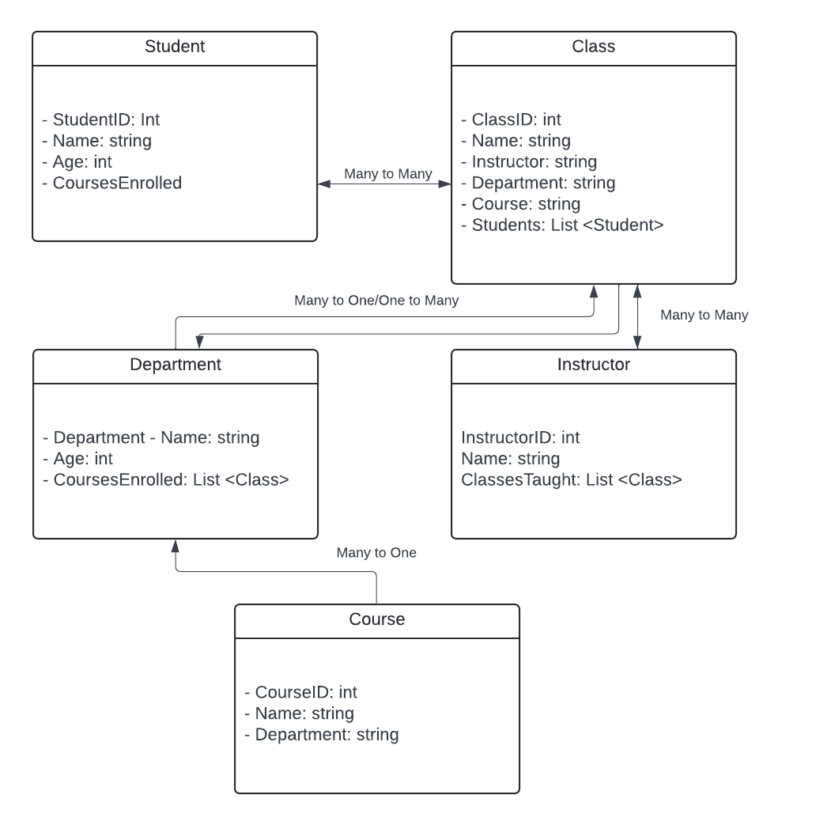

Class Implementation:

Below are console source code snippets for each class containing their attributes and methods:

“Student” Class:



“Class” Class:



“Department” Class:



“Instructor” Class:



“Course” Class



Testing

Lastly, we created a Program class with a static main entry clause that uses Console.WriteLine statements to display example output for testing purposes:



Output:

